**FOLLOW FOR MORE:- https://www.bezkoder.com/category/spring/**

**Spring Boot JdbcTemplate example with MySQL: CRUD App**

[Last modified: March 29, 2022](https://www.bezkoder.com/spring-boot-jdbctemplate-example-mysql/)  [bezkoder](https://www.bezkoder.com/author/bezkoder/)  [Spring](https://www.bezkoder.com/category/spring/)

In this tutorial, we’re gonna build a Spring Boot Rest CRUD API example that use Spring [JdbcTemplate](https://docs.spring.io/spring-framework/docs/current/javadoc-api/org/springframework/jdbc/core/JdbcTemplate.html) to interact with MySQL database. You’ll know:

* How to configure Spring Data JDBC to work with Database
* How to define Data Models and Repository interfaces
* Way to create Spring Rest Controller to process HTTP requests
* Way to use Spring JdbcTemplate to interact with MySQL Database

Exception Handling:  
– [Spring Boot @ControllerAdvice & @ExceptionHandler example](https://bezkoder.com/spring-boot-controlleradvice-exceptionhandler/)  
– [@RestControllerAdvice example in Spring Boot](https://bezkoder.com/spring-boot-restcontrolleradvice/)

Unit Test:  
[Spring Boot – Rest Controller Unit Test with @WebMvcTest](https://www.bezkoder.com/spring-boot-webmvctest/)

Using Spring Data JPA instead:  
[Spring Boot, Spring Data JPA, MySQL example](https://www.bezkoder.com/spring-boot-jpa-crud-rest-api/)

This Spring Boot App works with Client in one of these posts:

* [Simple HTTP Client using Axios](https://www.bezkoder.com/axios-request/)
* [Simple HTTP Client using Fetch API](https://www.bezkoder.com/javascript-fetch/)
* [Angular 8](https://bezkoder.com/angular-crud-app/) / [Angular 10](https://bezkoder.com/angular-10-crud-app/) / [Angular 11](https://bezkoder.com/angular-11-crud-app/) / [Angular 12](https://bezkoder.com/angular-12-crud-app/)
* [Vue 2](https://bezkoder.com/vue-js-crud-app/) / [Vue 3](https://bezkoder.com/vue-3-crud/)
* [React](https://bezkoder.com/react-crud-web-api/) / [React Redux](https://www.bezkoder.com/react-redux-crud-example/)

Other Databases:  
– [Spring Boot JdbcTemplate example with H2](https://www.bezkoder.com/spring-boot-jdbctemplate-crud-example/)  
– [Spring Boot JdbcTemplate example with PostgreSQL](https://www.bezkoder.com/spring-boot-jdbctemplate-postgresql-example/)

**Contents**[[hide](https://www.bezkoder.com/spring-boot-jdbctemplate-example-mysql/)]

* [Overview](https://www.bezkoder.com/spring-boot-jdbctemplate-example-mysql/#Overview)
* [Technology](https://www.bezkoder.com/spring-boot-jdbctemplate-example-mysql/#Technology)
* [Project Structure](https://www.bezkoder.com/spring-boot-jdbctemplate-example-mysql/#Project_Structure)
* [Create & Setup Spring Boot project](https://www.bezkoder.com/spring-boot-jdbctemplate-example-mysql/#Setup)
* [Configure Spring Data and MySQL database](https://www.bezkoder.com/spring-boot-jdbctemplate-example-mysql/#Configuring)
* [Define Data Model](https://www.bezkoder.com/spring-boot-jdbctemplate-example-mysql/#Define_Data_Model)
* [Create Repository](https://www.bezkoder.com/spring-boot-jdbctemplate-example-mysql/#Create_Repository)
* [Create Spring Rest APIs Controller](https://www.bezkoder.com/spring-boot-jdbctemplate-example-mysql/#Create_Controller)
* [Run & Check](https://www.bezkoder.com/spring-boot-jdbctemplate-example-mysql/#Run)
* [Conclusion](https://www.bezkoder.com/spring-boot-jdbctemplate-example-mysql/#Conclusion)
* [Source Code](https://www.bezkoder.com/spring-boot-jdbctemplate-example-mysql/#Source_Code)
* [Further Reading](https://www.bezkoder.com/spring-boot-jdbctemplate-example-mysql/#Further_Reading)

**Overview of Spring Boot JdbcTemplate and MySQL example**

We will build a Spring Boot Rest API using Spring Data Jdbc with MySQL Database for a Tutorial application that:

* Each Tutorial has id, title, description, published status.
* Apis help to create, retrieve, update, delete Tutorials.
* Apis also support custom finder methods such as find by published status or by title.

These are APIs that we need to provide:

| **Methods** | **Urls** | **Actions** |
| --- | --- | --- |
| POST | /api/tutorials | create new Tutorial |
| GET | /api/tutorials | retrieve all Tutorials |
| GET | /api/tutorials/:id | retrieve a Tutorial by :id |
| PUT | /api/tutorials/:id | update a Tutorial by :id |
| DELETE | /api/tutorials/:id | delete a Tutorial by :id |
| DELETE | /api/tutorials | delete all Tutorials |
| GET | /api/tutorials/published | find all published Tutorials |
| GET | /api/tutorials?title=[keyword] | find all Tutorials which title contains keyword |

– We make CRUD operations & finder methods with Spring Data Jdbc.  
– The database will be MySQL by configuring project dependency & datasource.

**Technology**

* Java 8
* Spring Boot 2.5.5 (with Spring Web MVC, Spring Data JDBC)
* MySQL Database
* Maven 3.6.1

**Project Structure**

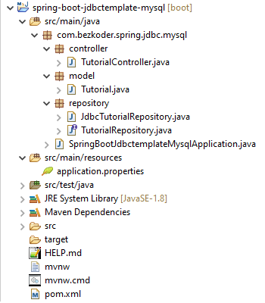

Let me explain it briefly.

– Tutorial data model class corresponds to entity and table *tutorials*.  
– TutorialRepository is an interface that provides abstract methods for CRUD Operations and custom finder methods. It will be autowired in TutorialController.  
– JdbcTutorialRepository implements TutorialRepository. It uses [JdbcTemplate](https://docs.spring.io/spring-framework/docs/current/javadoc-api/org/springframework/jdbc/core/JdbcTemplate.html) for executing SQL queries or updates to interact with Database.  
– TutorialController is a [RestController](https://docs.spring.io/spring/docs/current/javadoc-api/org/springframework/web/bind/annotation/RestController.html) which has request mapping methods for RESTful requests such as: *getAllTutorials*, *createTutorial*, *updateTutorial*, *deleteTutorial*, *findByPublished*…  
– Configuration for Spring Datasource, MySQL database in **application.properties**.  
– **pom.xml** contains dependencies for Spring Boot Web, JDBC and MySQL Connector.

**Create & Setup Spring Boot project**

Use [Spring web tool](https://start.spring.io/) or your development tool ([Spring Tool Suite](https://spring.io/tools), Eclipse, [Intellij](https://www.jetbrains.com/idea/download/)) to create a Spring Boot project.

Then open **pom.xml** and add these dependencies:

<dependency>

<groupId>org.springframework.boot</groupId>

<artifactId>spring-boot-starter-data-jdbc</artifactId>

</dependency>

<dependency>

<groupId>org.springframework.boot</groupId>

<artifactId>spring-boot-starter-web</artifactId>

</dependency>

<dependency>

<groupId>mysql</groupId>

<artifactId>mysql-connector-java</artifactId>

<scope>runtime</scope>

</dependency>

**Configure Spring Data and MySQL database**

Under **src**/**main**/**resources** folder, open *application.properties* and write these lines.

spring.datasource.url= jdbc:mysql://localhost:3306/testdb?useSSL=false

spring.datasource.username= root

spring.datasource.password= 123456

spring.datasource.username & spring.datasource.password properties are the same as your database installation.

**Define Data Model**

Our Data model is Tutorial with four fields: id, title, description, published.  
In **model** package, we define Tutorial class.

*model/Tutorial.java*

package com.bezkoder.spring.jdbc.mysql.model;

public class Tutorial {

private long id;

private String title;

private String description;

private boolean published;

public Tutorial() {

}

public Tutorial(long id, String title, String description, boolean published) {

this.id = id;

this.title = title;

this.description = description;

this.published = published;

}

public Tutorial(String title, String description, boolean published) {

this.title = title;

this.description = description;

this.published = published;

}

public void setId(long id) {

this.id = id;

}

public long getId() {

return id;

}

public String getTitle() {

return title;

}

public void setTitle(String title) {

this.title = title;

}

public String getDescription() {

return description;

}

public void setDescription(String description) {

this.description = description;

}

public boolean isPublished() {

return published;

}

public void setPublished(boolean isPublished) {

this.published = isPublished;

}

@Override

public String toString() {

return "Tutorial [id=" + id + ", title=" + title + ", desc=" + description + ", published=" + published + "]";

}

}

**Create JDBC Repository**

Let’s create a repository to interact with Tutorials from the database.

In **repository** package, create TutorialRepository interface that provides abstract methods:

* for CRUD Operations: save, findById, findAll, update, deleteById, deleteAll.
* custom finder methods: findByPublished, findByTitleContaining.

*repository/TutorialRepository.java*

package com.bezkoder.spring.jdbc.mysql.repository;

import java.util.List;

import com.bezkoder.spring.jdbc.mysql.model.Tutorial;

public interface TutorialRepository {

int save(Tutorial book);

int update(Tutorial book);

Tutorial findById(Long id);

int deleteById(Long id);

List<Tutorial> findAll();

List<Tutorial> findByPublished(boolean published);

List<Tutorial> findByTitleContaining(String title);

int deleteAll();

}

We continue to define JdbcTutorialRepository which implements TutorialRepository. It uses JdbcTemplate object for executing SQL queries or updates to interact with MySQL Database.

*repository/JdbcTutorialRepository.java*

package com.bezkoder.spring.jdbc.mysql.repository;

import java.util.List;

import org.springframework.beans.factory.annotation.Autowired;

import org.springframework.dao.IncorrectResultSizeDataAccessException;

import org.springframework.jdbc.core.BeanPropertyRowMapper;

import org.springframework.jdbc.core.JdbcTemplate;

import org.springframework.stereotype.Repository;

import com.bezkoder.spring.jdbc.mysql.model.Tutorial;

@Repository

public class JdbcTutorialRepository implements TutorialRepository {

@Autowired

private JdbcTemplate jdbcTemplate;

@Override

public int save(Tutorial tutorial) {

return jdbcTemplate.update("INSERT INTO tutorials (title, description, published) VALUES(?,?,?)",

new Object[] { tutorial.getTitle(), tutorial.getDescription(), tutorial.isPublished() });

}

@Override

public int update(Tutorial tutorial) {

return jdbcTemplate.update("UPDATE tutorials SET title=?, description=?, published=? WHERE id=?",

new Object[] { tutorial.getTitle(), tutorial.getDescription(), tutorial.isPublished(), tutorial.getId() });

}

@Override

public Tutorial findById(Long id) {

try {

Tutorial tutorial = jdbcTemplate.queryForObject("SELECT * FROM tutorials WHERE id=?",

BeanPropertyRowMapper.newInstance(Tutorial.class), id);

return tutorial;

} catch (IncorrectResultSizeDataAccessException e) {

return null;

}

}

@Override

public int deleteById(Long id) {

return jdbcTemplate.update("DELETE FROM tutorials WHERE id=?", id);

}

@Override

public List<Tutorial> findAll() {

return jdbcTemplate.query("SELECT * from tutorials", BeanPropertyRowMapper.newInstance(Tutorial.class));

}

@Override

public List<Tutorial> findByPublished(boolean published) {

return jdbcTemplate.query("SELECT * from tutorials WHERE published=?",

BeanPropertyRowMapper.newInstance(Tutorial.class), published);

}

@Override

public List<Tutorial> findByTitleContaining(String title) {

String q = "SELECT * from tutorials WHERE title LIKE '%" + title + "%'";

return jdbcTemplate.query(q, BeanPropertyRowMapper.newInstance(Tutorial.class));

}

@Override

public int deleteAll() {

return jdbcTemplate.update("DELETE from tutorials");

}

}

– JDBCTemplate implements JdbcOperations which provides useful methods: execute(), query(), update(), queryForObject()…  
– BeanPropertyRowMapper implements RowMapper that converts a table row into a new instance of the specified mapped target class (Tutorial).  
– Tutorial class must be a top-level class and have a default constructor (no-argument).

**Create Spring Rest APIs Controller**

Finally, we create a controller that provides APIs for creating, retrieving, updating, deleting and finding Tutorials.

*controller/TutorialController.java*

package com.bezkoder.spring.jdbc.mysql.controller;

import java.util.ArrayList;

import java.util.List;

import org.springframework.beans.factory.annotation.Autowired;

import org.springframework.http.HttpStatus;

import org.springframework.http.ResponseEntity;

import org.springframework.web.bind.annotation.CrossOrigin;

import org.springframework.web.bind.annotation.DeleteMapping;

import org.springframework.web.bind.annotation.GetMapping;

import org.springframework.web.bind.annotation.PathVariable;

import org.springframework.web.bind.annotation.PostMapping;

import org.springframework.web.bind.annotation.PutMapping;

import org.springframework.web.bind.annotation.RequestBody;

import org.springframework.web.bind.annotation.RequestMapping;

import org.springframework.web.bind.annotation.RequestParam;

import org.springframework.web.bind.annotation.RestController;

import com.bezkoder.spring.jdbc.mysql.model.Tutorial;

import com.bezkoder.spring.jdbc.mysql.repository.TutorialRepository;

@CrossOrigin(origins = "http://localhost:8081")

@RestController

@RequestMapping("/api")

public class TutorialController {

@Autowired

TutorialRepository tutorialRepository;

@GetMapping("/tutorials")

public ResponseEntity<List<Tutorial>> getAllTutorials(@RequestParam(required = false) String title) {

try {

List<Tutorial> tutorials = new ArrayList<Tutorial>();

if (title == null)

tutorialRepository.findAll().forEach(tutorials::add);

else

tutorialRepository.findByTitleContaining(title).forEach(tutorials::add);

if (tutorials.isEmpty()) {

return new ResponseEntity<>(HttpStatus.NO_CONTENT);

}

return new ResponseEntity<>(tutorials, HttpStatus.OK);

} catch (Exception e) {

return new ResponseEntity<>(null, HttpStatus.INTERNAL_SERVER_ERROR);

}

}

@GetMapping("/tutorials/{id}")

public ResponseEntity<Tutorial> getTutorialById(@PathVariable("id") long id) {

Tutorial tutorial = tutorialRepository.findById(id);

if (tutorial != null) {

return new ResponseEntity<>(tutorial, HttpStatus.OK);

} else {

return new ResponseEntity<>(HttpStatus.NOT_FOUND);

}

}

@PostMapping("/tutorials")

public ResponseEntity<String> createTutorial(@RequestBody Tutorial tutorial) {

try {

tutorialRepository.save(new Tutorial(tutorial.getTitle(), tutorial.getDescription(), false));

return new ResponseEntity<>("Tutorial was created successfully.", HttpStatus.CREATED);

} catch (Exception e) {

return new ResponseEntity<>(null, HttpStatus.INTERNAL_SERVER_ERROR);

}

}

@PutMapping("/tutorials/{id}")

public ResponseEntity<String> updateTutorial(@PathVariable("id") long id, @RequestBody Tutorial tutorial) {

Tutorial _tutorial = tutorialRepository.findById(id);

if (_tutorial != null) {

_tutorial.setId(id);

_tutorial.setTitle(tutorial.getTitle());

_tutorial.setDescription(tutorial.getDescription());

_tutorial.setPublished(tutorial.isPublished());

tutorialRepository.update(_tutorial);

return new ResponseEntity<>("Tutorial was updated successfully.", HttpStatus.OK);

} else {

return new ResponseEntity<>("Cannot find Tutorial with id=" + id, HttpStatus.NOT_FOUND);

}

}

@DeleteMapping("/tutorials/{id}")

public ResponseEntity<String> deleteTutorial(@PathVariable("id") long id) {

try {

int result = tutorialRepository.deleteById(id);

if (result == 0) {

return new ResponseEntity<>("Cannot find Tutorial with id=" + id, HttpStatus.OK);

}

return new ResponseEntity<>("Tutorial was deleted successfully.", HttpStatus.OK);

} catch (Exception e) {

return new ResponseEntity<>("Cannot delete tutorial.", HttpStatus.INTERNAL_SERVER_ERROR);

}

}

@DeleteMapping("/tutorials")

public ResponseEntity<String> deleteAllTutorials() {

try {

int numRows = tutorialRepository.deleteAll();

return new ResponseEntity<>("Deleted " + numRows + " Tutorial(s) successfully.", HttpStatus.OK);

} catch (Exception e) {

return new ResponseEntity<>("Cannot delete tutorials.", HttpStatus.INTERNAL_SERVER_ERROR);

}

}

@GetMapping("/tutorials/published")

public ResponseEntity<List<Tutorial>> findByPublished() {

try {

List<Tutorial> tutorials = tutorialRepository.findByPublished(true);

if (tutorials.isEmpty()) {

return new ResponseEntity<>(HttpStatus.NO_CONTENT);

}

return new ResponseEntity<>(tutorials, HttpStatus.OK);

} catch (Exception e) {

return new ResponseEntity<>(HttpStatus.INTERNAL_SERVER_ERROR);

}

}

}

– @CrossOrigin is for configuring allowed origins.  
– @RestController annotation is used to define a controller and to indicate that the return value of the methods should be be bound to the web response body.  
– @RequestMapping("/api") declares that all Apis’ url in the controller will start with /api.  
– We use @Autowired to inject TutorialRepository bean to local variable.

**Run & Check**

Run Spring Boot application with command: mvn spring-boot:run.

write SQL script to create **tutorials** table:

CREATE TABLE tutorials

(

id BIGINT NOT NULL PRIMARY KEY AUTO_INCREMENT,

title VARCHAR(255),

description VARCHAR(255),

published BOOLEAN

);

Create some Tutorials:

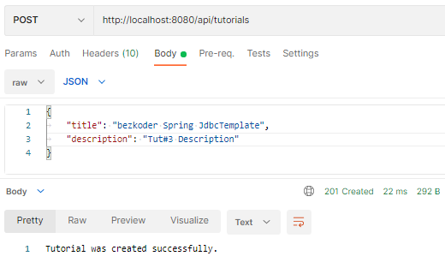

MySQL database tutorials table after that:

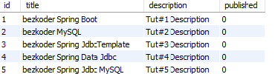

Update some Tutorials:

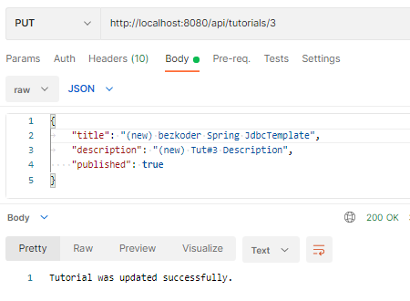

The table data is changed:

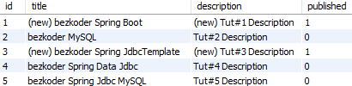

Retrieve all Tutorials:

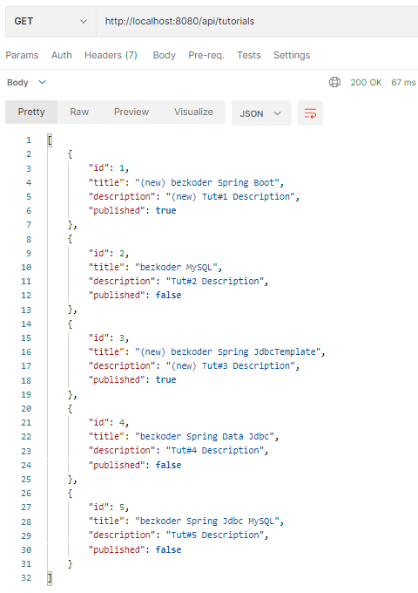

Retrieve a Tutorial by Id:

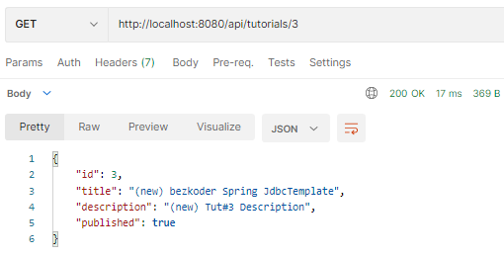

Find all ***published*** Tutorials:

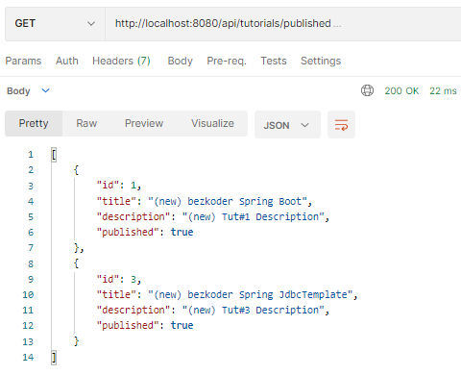

Find all Tutorials which title contains string ‘jdbc’:

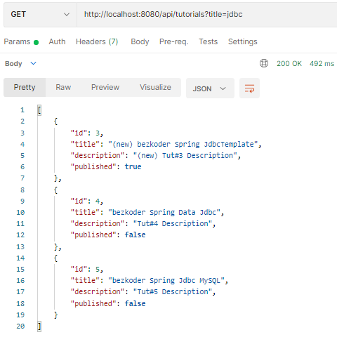

Delete a Tutorial:

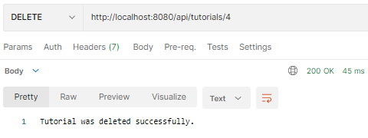

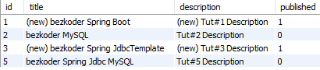

Delete all Tutorials:

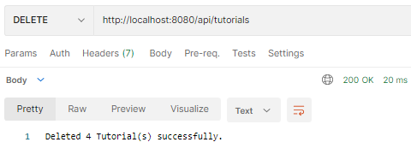

Database table is clean now.